Allocation Group Creation Process: How it Works and Testing

Process looks to property attributes to find the pumper, foreman and basin for cost allocation groups.

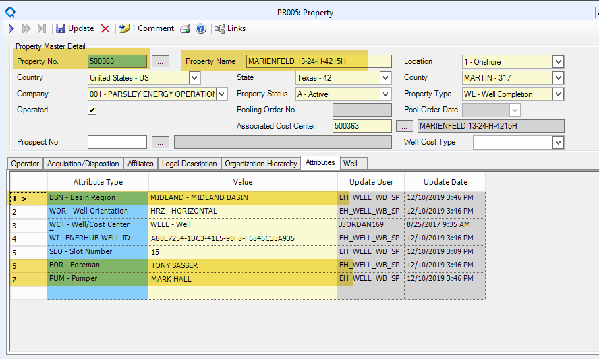

Process Logic

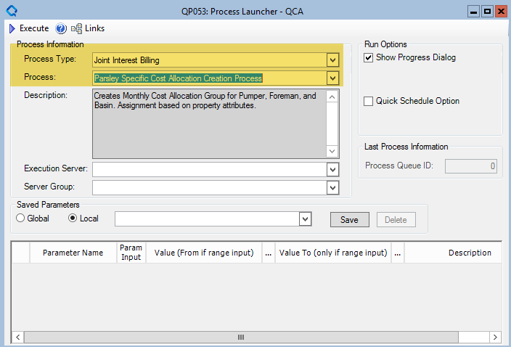

1. The process finds the most recent JIB process month.

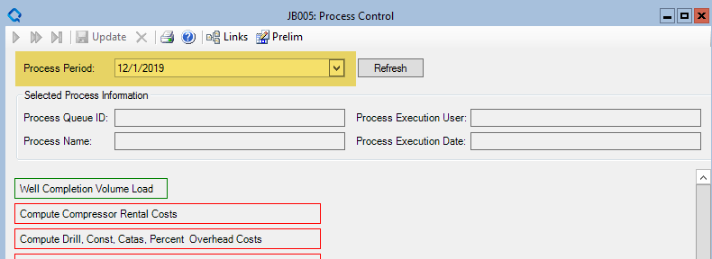

1. End dates all corresponding pumper/foreman/basin allocation groups that span past the current month.

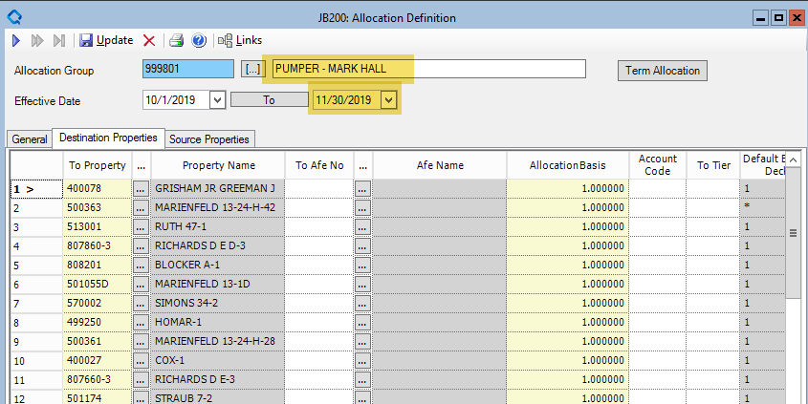

1. Process creates new allocation group details by looking up which allocation group name correspond with the property’s attributes.

